Intelligent Assistive Model for the Visually Impaired AI-based Automatic Road Network Extraction from Satellite Imagery
Contributors: Guide:
Aditya Ranganathan Arun (CS22B1002) Dr. Venkatesan M.
Annisha Rachel de Souza (CS22B1004) Associate Professor & HoD
Shivakumar B. (CS22B1052)
Aim: To provide government agencies with an automatic road network extraction tool using AI that overcomes the innate challenges that exist in satellite imagery.
Objectives:
- To develop a deep learning segmentation model to accurately extract road interiors and boundaries from high‑resolution Cartosat and Resourcesat satellite imagery.
- To design algorithms to handle occlusions (buildings, trees, shadows) and infer continuous road segments even when partially obscured.
- To convert segmented road masks into a topologically correct vector network that preserves geometric features (roundabouts, junctions) and removes noise.
- To develop a frontend for the user interface to upload satellite images.
- To develop a fully automated pipeline suitable for integration with ISRO's geospatial platforms (Bhuvan) and government agencies (MoRTH, MoUHA).

Proposed methodology:
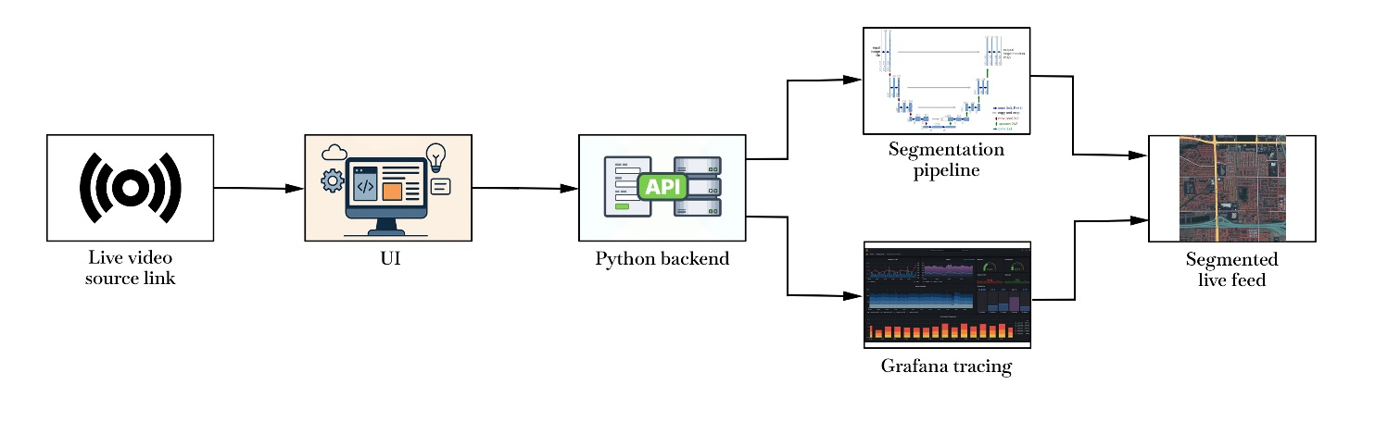
Expected Outcomes:
- Accurate deep learning–based extraction of road interiors and boundaries from Cartosat and Resourcesat imagery.
- Generation of clean, topologically correct vector road networks with preserved junctions and roundabouts.
- Fully automated end-to-end pipeline from data ingestion to vector output with minimal manual intervention.
- User-friendly web interface for uploading and processing satellite streaming links.
- Integration-ready, scalable system with trace monitoring to ensure reliability and low downtime for deployment on ISRO and government platforms.

